Colic Information Sheet

What is colic?

Colic means pain in the abdomen, i.e. the bit behind the heart and lungs. It is most commonly pain originating in the guts but can come from other organs in the abdomen e.g. the liver, kidneys and bladder.

What are the signs of colic?

Often the horse will swish its tail, be agitated, look round at its belly and sometime kick at their belly. When it gets more uncomfortable, they may lie down which can progress to rolling, as they attempt to relieve their pain.

Can you fix it?

Colic can be severe, and everyone knows a story of a horse with twisted guts which either had to be put down or was referred to a vet hospital. Fortunately, most bouts of colic are not that severe and can be treated at the yard by your vet.

What are the different types of colic?

There are several types of less severe colics that are treated “stable-side” and these include: gassy/spasmodic colics, impaction colics and sometimes mild displacements.
Gassy colics are those where there’s a build-up of gas in one bit of large colon where the gut acts as a fermentation chamber- “clues in the name”! The stretch of the gut wall can be very painful, but this type of pain often comes and goes as gas moves along the gut.
Impaction colics are where there is a blockage of the gut, usually with food material, and is commonly found at two sites where there’s a bit of a bottle neck in the guts: the ileum, which is the last bit of the small intestine and the pelvic flexure which is in the middle of the large colon.
Mild displacements occur when one of the bits of large colon has moved into the wrong place and is often due to gas build up.
The most severe type of colic is termed “surgical colic” which is one of the many types which can only be fixed by opening them up and sorting it out, thankfully this is rare.

What do I do if my horse is showing signs of colic?
Call your vet and importantly don’t get hurt yourself, as horses in pain are unpredictable. Put a lunge line on the horse and move them to the schooling arena, or if not available to a field. If they lie down flat out you can leave them be, but if they want to start rolling its best to keep them walking. Lunging at walk and trot can be useful for many types of colic.

Is colic surgery worth it?

It’s obviously a very individual choice as it’s a very expensive undertaking £4-7000 can be expected. However, many studies show success rates in the 80% or above range with success being the horse back in full work. One of the surgical types of colic is where a piece of small intestine has lost its blood supply and has to be removed see pictures A and B.

How to prevent colic?

Try to make feed and management changes slowly. When changing from hay to haylage do it over a 10-day period. When turning out onto good quality grass do so for an hour a day to start with, or strip-graze. If the opposite is true and your grazing horse has to be box-rested then try to soak their hay, pick fresh grass and if possible, get them walking in hand to graze.

Picture A Picture B
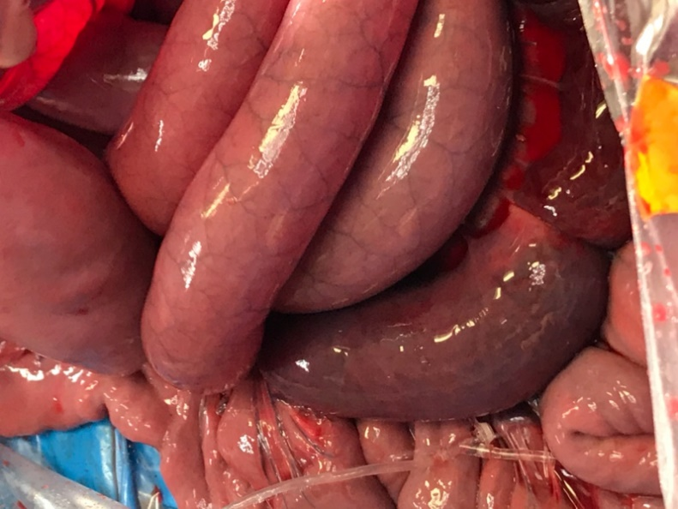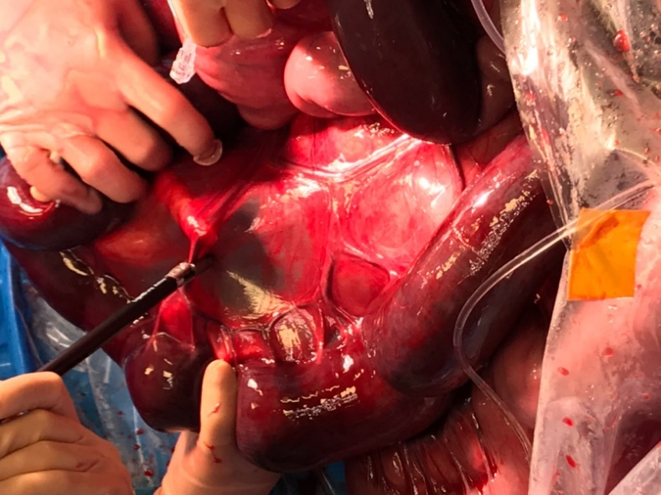
Picture A shows healthy but distended small intestine on the right and the unhealthy section is dark and bottom left of the photo. Picture B shows the unhealthy (dark red) section of small intestine being removed

